Business Model:

Cathay Pacific



Margherita Botticelli

Nicola Bozzi

Andrea Cadoni

Eneriko Caushllari

Benedetta Pajadan

Francesca Rignanese

1. BUSINESS MODEL CANVAS

A business model describes the rationale of how an organization creates, delivers, and captures value. Entrepreneurs need to develop and refine a business model for themselves as they seek clarity about what they are doing, and also for discussing with colleagues, partners, and other stakeholders.

In the following we will give a short description of the building blocks that constitute our BMC.

**Value Proposition**: Cathay wants to deliver a premium customer experience. It positions itself as an airline offering quality services from the heart. “People and Services” is the current brand building campaign for strengthening this position. Key points are in-flight entertainment, delicious food, friendly service and luxurious Business class. Its purpose is to move people forward in life through the ability to connect them to meaningful people, places and experiences. Embedded in this philosophy is being able to achieve this purpose sustainably and ensuring future generations the right to enjoy full, well-traveled lives as well.

**Key partners**: Cathay Pacific has put much effort on building long-term relationships with its partners. Oneworld is a global airline alliance initiated by Cathay Pacific; through it Cathay Pacific established a global network with 14 airlines, sharing a larger base of customers. Recently, Cathay Pacific has signed a content agreement with Amadeus offering agents access to a comprehensive range of Cathay Pacific and Dragonair fares, schedules and availability.

Codeshare agreements allow Cathay to offer better connections around the world and greater flexibility in planning the trip. Cathay Pacific currently has codeshare agreements with a number of other international airlines like Air China, Air Canada, Air Astana and others.

Joint Operating Services (JOS) or Strategic Agreement is a cooperative agreement between two or more airlines to offer joint services on specific routes of their network. Customers can enjoy enhanced benefits such as codeshare, better connections and frequent flier services with more earn-and-redeem opportunities. Cathay has these agreements with Air China for the flights between Hong Kong and Beijing, Chengdu, Chongqing and also with Air New Zealand for the flights between Hong Kong and Auckland and Christchurch.

**Key resources**: Cathay’'s most important assets are its airplanes and its people. An airline can have the best planes in the world, but without the employees, an airline can't do anything.

Cathay Pacific Airway builds a strong market brand through presenting its brand in a unique way, such as offering excellent services to the customers, creating an emotional connection with them, and internalizing its brand with internal employees.

**Key activities**: Cathay airlines has multiple activities in their business strategy, they not only offer people transportation but also cargo transportation. They also have Cathay which is the new premium travel lifestyle brand that promises to bring in the customer everyday life what they love to do on a flight. A new series dedicated to food, shopping, and comfort, now not only when you travel but also in your daily life.

They give an impressive customer service, for complaint but also on board giving the customer one of the best flight experiences. Some of their major brands are Cathay Pacific, Cathay Dragon, Cathays Holidays Limited and Cathay Pacific Catering Services (HK) Limited.

**Customer relationship**: Cathay Pacific handles customer complaints through multiple channels such as comment cards, web site and frontline staff because number of complaints is an indicator which can reflect customer satisfaction indirectly. In addition, Cathay Pacific continually carries out customer satisfaction surveys proactively. Cathay Pacific also manages a two-tiered loyalty program to maintain and enhance customer loyalty. The Marco Polo Club is a loyalty program that offers a range of privileges to Cathay most frequent flyers.

**Channels**: the channels used to communicate with customers are the typical ones: they have a website where you can search and book your flights, then they have travel agencies (which is their preferred booking channel), they also have lots of social media and a news hub part in their website where you can read stories, fact sheets and you can find their media gallery. They operate in social media like Facebook, Instagram, Twitter, LinkedIn and YouTube.   
In addition, they have developed their own mobile application used by customers to get relevant information about flights.

**Customer segments**: Seventy-five percent Cathay customers were Asian, with increasing numbers from Taiwan, Hong Kong, Singapore and Japan (Source: Cathay Pacific Airways Limited Interim Report 2013). The company has targeted middle, upper middle and business corporate as its [target](https://www.marketing91.com/swot-analysis-target/) customers who prefer reliable flights and comfortable services. It has given a choice to its customer to choose a ticket that will be beneficial to the passenger. For itself, it has adopted a [competitive pricing](https://www.marketing91.com/competitive-pricing-competitive-pricing-strategy/) policy because it faces a lot of rivalry in the airline industry.

Cathay Pacific Cargo has developed a wide range of service options to meet the growing needs of its customers. Cathay Pacific Cargo products include Wine LIFT, Pharma LIFT, Priority LIFT, DG LIFT, Fresh LIFT, Live Animal LIFT, Secure LIFT, Courier LIFT and Expert LIFT.

**Cost structure**: Purchase Planes and Equipment: The cost of the aircraft is obviously a major part of airline costs. Typical accounting measures (as discussed in this 2018 [FAA guide](https://www.faa.gov/regulations_policies/policy_guidance/benefit_cost/media/econ-value-section-4-op-costs.pdf) to airline costs) suggest a depreciation cost of 4% per year for jet aircraft. This would roughly assume a 25-year operating life for an aircraft.

Maintenance: Aircraft undergo regular checks and maintenance as part of daily operations. This could be considered as either fixed or dependent on flights. Like all fixed costs, there is a cost that needs to be attributed to each flight made. But to maintain an airworthy fleet, maintenance costs are inevitable.

Insurance costs: Insuring aircraft will depend more on the fleet size than the number of flights.

Fuel: Fuel is a major expense for airlines and is why they suffer so much in periods of high oil prices. Many airlines will buy options for fuel ahead of time, locking in prices. This can make forward planning and accounting easier and provide some protection, but ultimately prices will rise when oil prices go up.

Airport Fees: Airlines pay a fee to land at any airport and use the required facilities there. Fees vary a great deal between airports and take into account different factors, including aircraft type and weight, landing time, and sometimes emissions and noise. Some locations split this into a fixed fee and a variable fee (based on the load-factor).

### Ground handling fees: As well as the fees to airports and governments for landing and using ground services, there are third parties involved in turning around and serving an aircraft. How much airlines handle themselves and how much is outsourced varies between airlines and locations.

Labor Costs/Staff training costs: Labor accounts for approximately 35% of the total of airlines' operating expenses. [Operating expenses](https://www.investopedia.com/terms/o/operating_expense.asp) account for roughly 75% of all non-fixed costs.

**Revenue streams**:

Cathay Pacific’s revenues are mostly made by passengers and cargo transportation, and at some little percentage by other services. Before Covid-19 more than 60% of revenues were made by passenger transportation, unfortunately due to covid the percentage heavily changed, putting cargo transportation as the main revenue stream for the company.

**Connections between Building blocks in the BMC**

1. High customer service + Staff and mobile app
2. Trust & reliability + Brand
3. Transparency + Comment cards and social media
4. Key activities (all) + Cost Structure (all)
5. Loyalty programs + Two-tiered loyalty program
6. Book flights & process payments + Channels (all)

2. VALUE PROPOSITION CANVAS

The Value Proposition Canvas is a framework which can help ensure that a product or service is positioned around what the customer values and needs.

In this case we analyzed the airways customers to understand what cathay pacific can offer to them.

We found out that what airways users want is not to lose time by traveling, being comfortable and feeling at home. What they don’t like is wasting time in: the queue, the car parking, the luggage management, a free space in the seat…  
What they want from the airways is to get to the destination, also in a comfortable way.

What Cathay offers is a set of services in-and-off plane, such as snacks and beverages, on board meals, wi-fi, airport lounges…

It provides connections with thousands of destinations and on time flights as well as on-board entertainment, they also provide different ways to buy tickets (on their own app and web site, via travel agents, company officials and airport counters), business class, MarcoPolo club and other facilities.

3. SWOT ANALYSIS

This paragraph’s aim is to make a SWOT analysis of the airline company Cathay Pacific, to understand what are the most valuable aspects of the company and to have a view of the aspects on which Cathay should focus on.

**STRENGTHS:**

1. The company has been present in the Airline market for a long time.

Cathay Pacific was founded in 1946 by Roy Farrell and Sydney de Kantzow, from America and Australia, respectively. Both founders were ex-Air Force pilots who served during World War II. Originally based in Shanghai, they moved to Hong Kong after the first few months of operation.

1. Cathay has a strong presence across regions, which leads to increased synergies of operations.

The company has operations in six regions: North Asia (Hong Kong, China Mainland, Japan, Korea and Taiwan, India, Middle East, Pakistan and Sri Lanka), Southwest Pacific and South Africa, Southeast Asia, Europe and North America.

1. The Customer Base of Cathay has a high degree of satisfaction.

The company is noted frequently for their excellent, attentive service, their cabin crew try to anticipate the needs of the customer in their first class cabin. Moreover, Cathay has some great reviews on [TripAdvisor](https://upgradedpoints.com/travel/tripadvisor/), with 72% of travelers rating them excellent or very good, 15% average, and 13% poor or terrible.

1. Cathay has a huge fleet and mix of aircrafts leading to optimum utilization of fleet based on demand conditions.

The company has a diverse fleet of aircrafts totaling 201 in numbers, which include a mix of Airbus and Boeing aircraft. The mixture of long and short haul aircrafts helps in reduction of operating costs along with increased flexibility in deployment of aircrafts, and in an optimum utilization of facilities based on demand conditions.

1. Code sharing agreements along with membership in OneWorld alliance.

Cathay Pacific currently has codeshare agreements with a big number of other international airlines. Entering into codeshare agreements allows the company to offer customers better connections around the world and greater flexibility in planning their trip. As a member of OneWorld alliance, the company can offer customers services like: more flight choices, smoother transfers for travels, access to more than 650 airport lounges, priority check-in and personal assistance from staff from all the alliance partners in the world.

**WEAKNESSES**:

1. Relying heavily on international onward moving traffic.

Without moving traffic, there will be less usage of its airline services as customers would choose other preferred airlines which are cost effective and less time consuming.

1. Limited market share due to extremely tough competition in the airlines segment.
2. Weak financials due to high leverage leading to difficulty in raising future finance.
3. Future finance liabilities leading to limited scope for future expansion.

Due to the big liabilities generated by the Covid-19 emergency, Cathay will have limited possibilities for a future expansion.

**OPPORTUNITIES:**

1. Cathay Pacific can leverage on the dedicated set of customers owing to the airline being in existence for a long time.
2. The company should focus on emerging market growth potential which would be the future growth driver for the company.
3. Technology backed services leading to improved operations and reduced costs related to Digital Transformation.
4. More expansion in the air freight sector in cargo hubs like Dubai.
5. Partnership with home-grown brands will add value to the company.

A better explanation of opportunities will be in the conclusion of this paper.

**THREATS:**

1. Intense competition in both domestic and international segments.

Due to the extremely high number of airline companies situated all around the world, the competition in the airline market is so intense that it is a threat for the company.

1. Volatility in jet fuel prices which is a significant operating expense for the company.

While jet fuel prices substantially declined at the onset of the Covid-19 pandemic, they bounced back sharply afterward because of inflationary pressures. This volatility makes the long-term planning of air operations more complex, prioritizing aircraft design and focusing on fuel efficiency.

1. Regulatory issues pertaining to continuing operation in both domestic and international segments.
2. General impact of social e and political issues like Covid-19 pandemic.

We now know that social and political issues like Covid-19 pandemic are not so far away from us, and that we have to stay alert in order to prevent any possible damage that could occur. It’s important to be aware of the high degree of uncertainty in the world of businesses.

4. ECONOMIC MODEL

The economic model below was done by dividing the life of the company in three main categories: costs, revenues and production. The line of thoughts we follow was that the **costs** incurred in 2021 **produced** specific services and assets which gave life to **revenues**.

For the numbers to have more context we compared them with the ones found for Singapore Airlines that has a similar Business model in respect to Cathay Pacific; doing so gave us the opportunity to sort of benchmark the results found and better understand what is going on in the economic model. Given that 2021 was the worst year in terms of Covid-19 the results are a bit off but the benchmark with Singapore airlines gives us the possibility to understand them a little better.

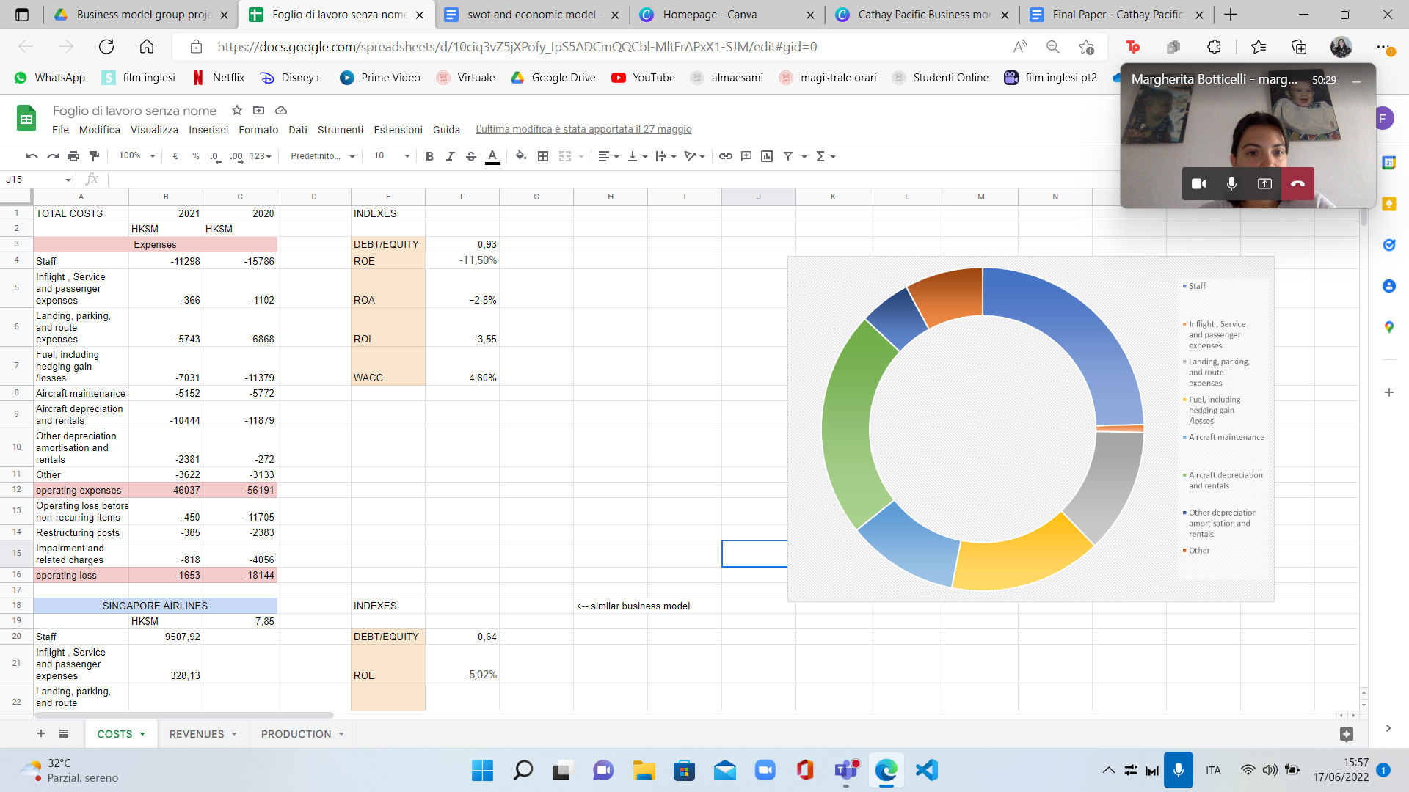

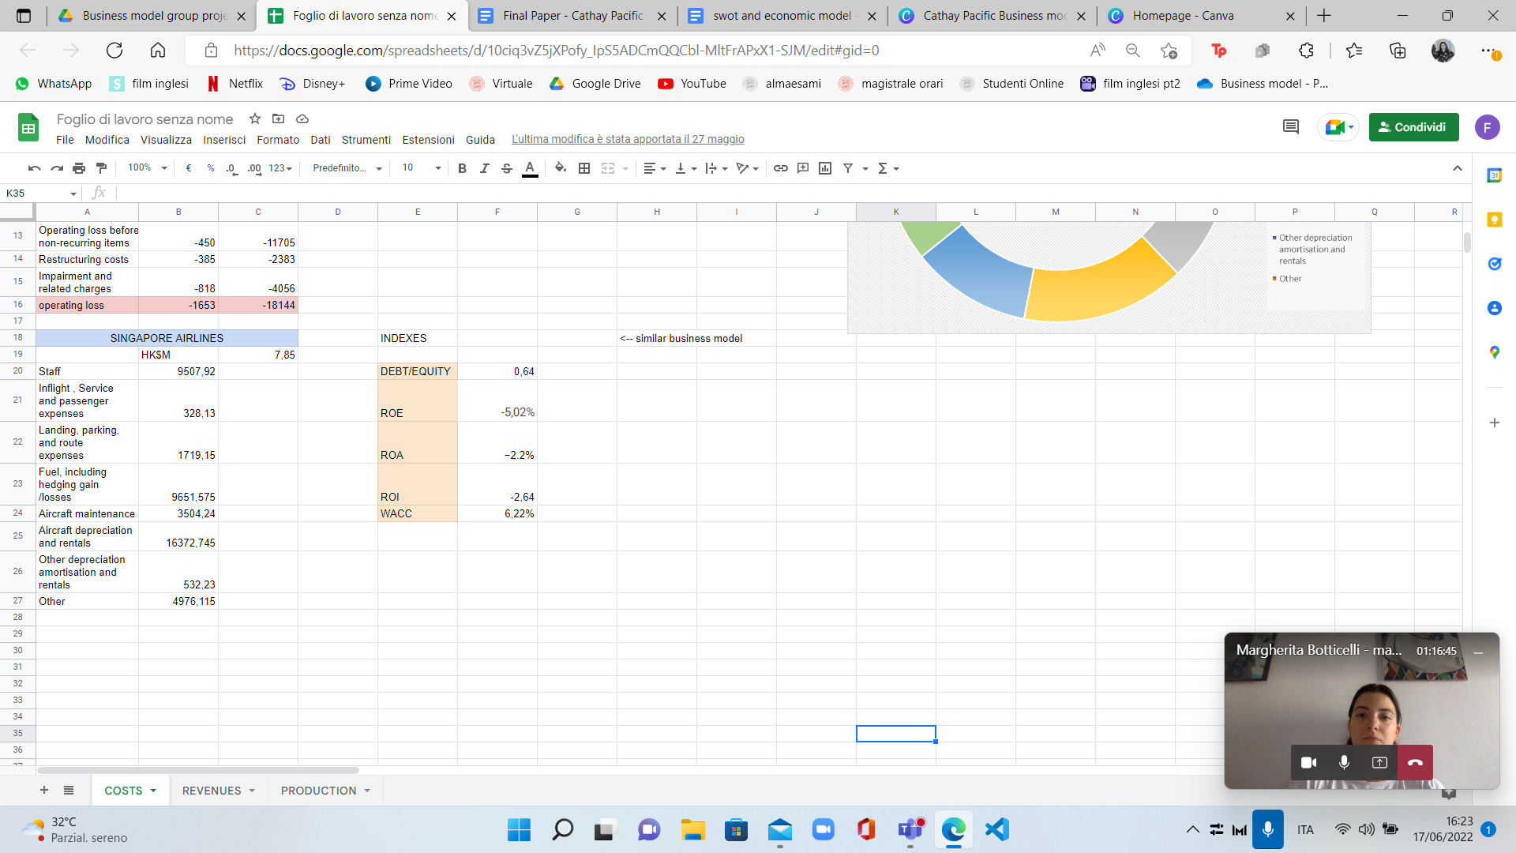

Regarding the costs: the biggest part is staff training as expected, as Cathay Pacific trains its own staff and wants to give the best experience to the customer through customer service; other important costs are aircraft depreciation and rentals as an airline company (fixed costs) is expected to have.

We also found some indexes which are not that positive but given the Covid situation in the last years it could be temporary.

Comparing our data, there is not that big of a difference with Singapore Airlines if it wasn’t for the ROE that is below 0 for both but Cathay has a much lower number. This could be explained by the fact that the average equity over time period is much higher for Singapore than it is for Cathay, but the net income is almost the same (CP - €6.001B and SA - €12.778B).

Then we have the production, Cathay has 170 total aircraft, 150 fleet and 20 cargo fleet, which are good numbers, also the other numbers (number of passenger and number of cargo) are a little biased because of covid.

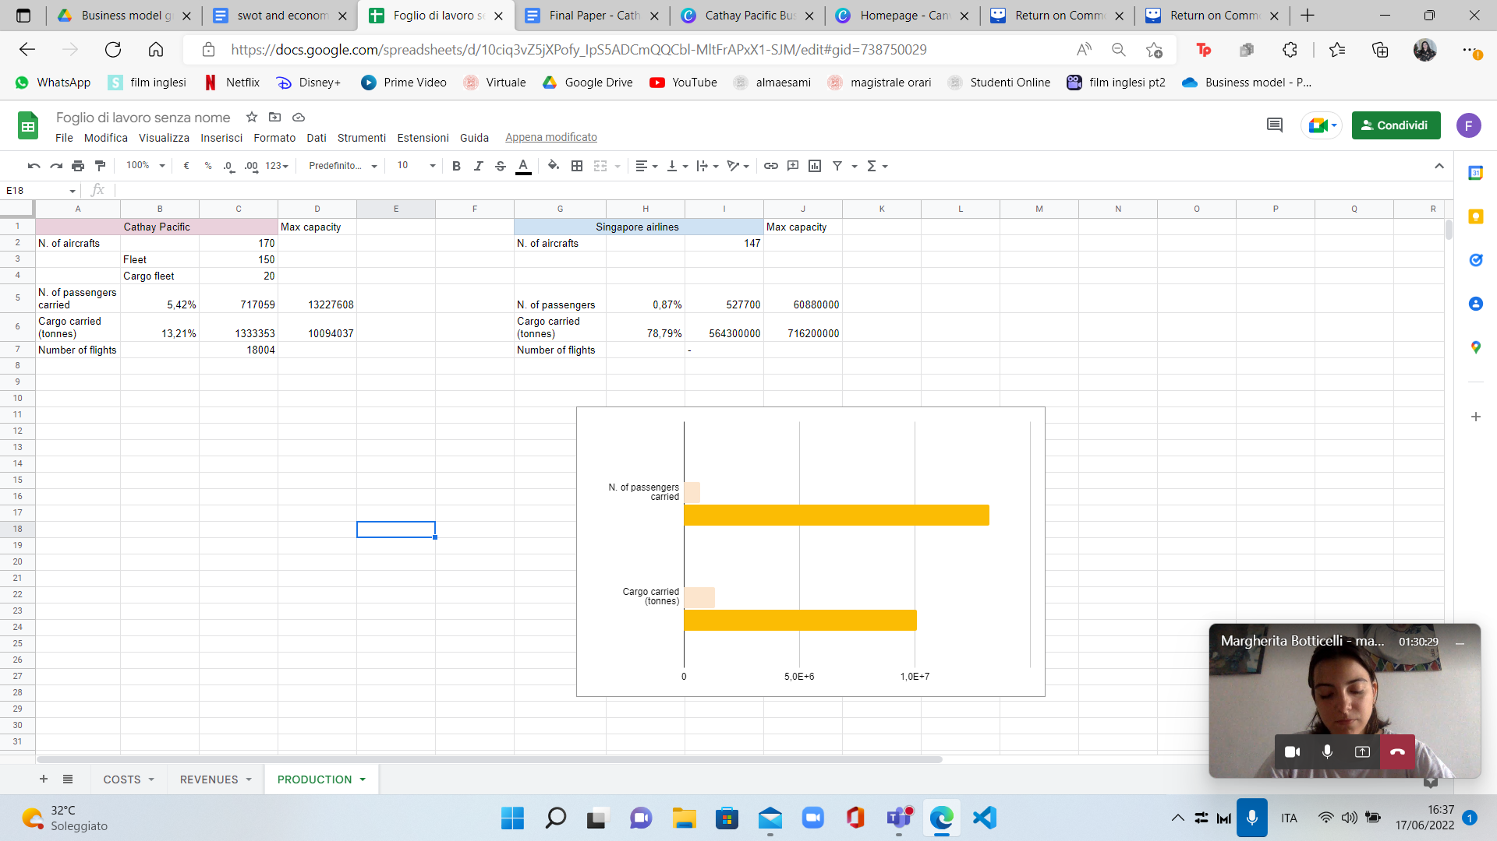



They don’t differ that much in number of aircraft, they do a little better in transport of passengers but definitely worse in transporting cargo even though for them cargo carried is better than passengers carried.

Lastly, we have revenues in which we can also observe the majority of it comes from cargo services, as expected form the previous part. The revenues for CP are also higher than Singapore. (See slides for comparison of revenues before and after Covid-19)

1. BUSINESS MODEL SCALABILITY

As stated in the paper “Building Scalable Business Models” (MIT Sloan Management Review, 59(2), 65-69) by Nielsen, C., & Lund, M. (2018), for a business model to be truly scalable, it ought to hold the promise of exponential increasing returns to scale. A Business Model that is agile and which provides exponentially increasing RtS in terms of growth from additional resources applied.

How Cathay Pacific was able to scale:

1. Scalability achieved adding new distribution channels: adding a new distribution channel provides additional value to existing channels and the customers using them. Long-term relationships with distributors and travel agencies have been critical for the success of Cathay Pacific. In particular the use of travel agencies has been a key sales channel for Cathay Pacific. Cathay has signed an agreement with “Amadeus'' ( a leading travel technology partner and transaction processor for the global travel and tourism industry) offering its agents access to a comprehensive range of fares. Another important distribution channel for Cathay exponential growth is the sophisticated internet booking system introduced in 2009.
2. Scalability through the leveraging of partners working for free: with a reputation for excellence and outstanding catering, most local travelers refuse to use any other airline. From Scalability point of view, this fidelity has been used to implement the fourth pattern of exponentially increasing Rts. The company was able to exploit customers' loyalty by having them working for free, promoting the brand and facilitating marketing efforts. This has also been used to enrich the value proposition (for free) creating a Virtual Community that facilitated the creation of loyalty, enabling interaction and service provision.
3. Overcome existing capacity constraints: This was obtained by constantly increasing the size of its fleet (Cathay Pacific has managed to maintain a modern fleet over its 75 years of operation and now has 239 aircraft) and forging a strong relationship with the Hong Kong airport. The latter operation allowed the company to overcome the runaway capacity constraint that is considered as one of the most problematic issues facing the airline industry. When runway capacity is not meeting demand, airlines may have to reduce flight frequencies and shift to larger aircraft sizes with higher operating costs.

6. CONCLUSIONS

By analyzing in depth the Business Model Canva above we were able to identify some of the value drivers of Cathay Pacific.

1. Customer Care and Customer loyalty: for sure the relationship with its customers is one of the main strength and value drivers as they offer multiple loyalty oriented programs. The organization, the “feel like at home” feeling, the quality of the flights are all key characteristics of Cathay Airlines that makes the customer want to fly again with the company. Also customer in flight services, customers before/after care services, are key features to strengthen the binding with their customers.
2. OneWorld alliance: Cathay Pacific has put much effort on building long-term relationships with its partners. Oneworld is a global airline alliance initiated by Cathay Pacific. Through Oneworld, Cathay Pacific established a global network with 11 airlines, sharing a larger base of customers. Thanks to it Cathay can offer a wider range of alliance fare and sales products. With Oneworld, passengers can plan their trip more flexibly because the members can offer a wide range of schedules, routes and destinations.
3. Business travels: The highest value for Cathay Pacific comes from business travelers—as opposed to those flying for leisure or personal reasons. Business travelers account for 12% of all airline passengers, but they tend to buy more expensive seats, buy last-minute tickets, and are typically twice as profitable as other passengers. In fact, on some flights, business passengers represent 75% of an airline's revenues.

Also the programs created for business traveling are value drivers as they give organized programs to the business to better plan their trips.

In addition to this general analysis we tried to find how the company could improve their performance by working on the Market traction.

6.1 MARKET TRACTION

The goal of Market traction for Cathay Pacific (it being an existing company) is to have faster revenue growth than competitors and new market penetration.

The main reason for focusing on Market Traction is to grow the business.

The lack of value proposition awareness is considered one of the most common issues in entrepreneurship.

The easiest way to identify potential reasons for lack of traction is by talking to potential and existing customers.

* **BRAND AWARENESS**

First and foremost, Cathay wants to deliver a premium customer experience, by positioning itself as an airline offering quality services from the heart. Therefore, it is considered the “Heart of Asia”, but despite that, if considered globally Cathay isn’t that famous. Consequently, Cathay should work on its Brand Awareness: starting from increasing the Brand Recognition to Visual Strategy, Branding and Social Media. To do so, the company would focus on emerging market growth potential, which would be the future growth driver for the company.

* **DIGITAL TRANSFORMATION**

Today, more than any other day is needed the digitalization of different fields, to have a positive influence in the company and in the economy.

Cathay should participate actively in digital innovation due to its cost structure, security dependence and competition intensity, to improve customer experience and financial performance.

The biggest technological buzz in the air travel industry is centred on Blockchain Technology. It is well known that Blockchain could be a game changer for flight operators, which can use it to transform their maintenance and safety regimes. Data entered into the blockchain would allow companies to track where every part on a plane came from and exactly who had handled it, and when – bringing security and

safety to new levels. This technology, of course, could be an advantage also for passengers.

By the way, The Cathay Pacific Group and Asia miles (its rewards programme) have launched their first application of Smart Blockchain Technology in a marketing campaign, in collaboration with Accenture. This allows Asia Miles, partners, and members a near real-time ability to manage rewards.

* **CATHAY PACIFIC CARGO**

Cathay Pacific Cargo shines in the Air Cargo World Customer Experience Survey: It has been considered top among Asia-Pacific Carriers across several metrics and also scored the highest among Asia-Pacific carriers across several measures including “timeliness”, “available space”, “maindeck capacity”, “perishables”, and “network” along with its “specialty cargo” plaudit.

Cathay Pacific Cargo holds accreditation for both CEIV Fresh and CEIV Pharma, IATA’s globally recognised quality assurance programmes for product handling. These ensure that pharmaceutical and perishable shipments are handled to exacting industry standards.

* **CUSTOMERS GREEN AWARENESS:**

People are more and more preoccupied with the sustainability of traveling, that is why Cathay Pacific is really committing to reaching net-zero carbon emissions by 2050 by pledging to use Sustainable Aviation Fuel (SAF) for 10% of its total fuel consumption by 2030.

FINAL CONSIDERATIONS

Cathay Pacific is a company primarily oriented toward the Business market.

Although it has already achieved excellent results in achieving its mission (to be considered the best company in the world) in our opinion there is still room for improvement, as highlighted in the Market Traction analysis.

The company is currently experiencing an extremely complex time. However, the causes are external to the business model, related almost exclusively to the pandemic situation to which Hong Kong has reacted extremely harshly and a fuel short operation gone wrong in 2016 in which the company lost 4.86 billion Hong Kong dollars (more or less 500 millions US Dollars). This gives hope, if the company can withstand the current difficulties, for a rapid recovery and an even greater growth.

The Covid-19 pandemic erased the revenues at a point in which in the last two years the main actor was the cargo transportation instead of the passenger one, due to the strict measures adopted by the world, and mostly by Asia, which is the main continent from which they get customers.

We believe that passengers will have a strong impact again in the revenues in the following years as the Covid-19 pandemic starts to disappear, but cargo still offers security, given that we live in uncertainty, and should be implemented just as we said in the market traction.

BIBLIOGRAPHY

“Building Scalable Business Models” (MIT Sloan Management Review, 59(2), 65-69) by Nielsen, C., & Lund, M. (2018)

“Cathay Pacific and Lufthansa Cargo expand joint business agreement to include Swiss WorldCargo” (Cathay Pacific - Stories - Official Website)

“Cathay Pacific Cargo sets new standard for cargo shipments with IATA ONE Record pilot in Hong Kong” (Cathay Pacific - Stories - Official Website)

“Market Traction: A Manual for Accelerating your Business Model” (Model Nielsen, C., Zaheer, H., Breyer, Y., Paolone, F., Montemari, M., & Lund, M. (2019).)

“Announcement - 2021 Annual Results” (Annual Report of Cathay Pacific - 2021)

“Annual Report and Sustainability Report” (Annual Report of Singapore Airlines 2021)

“THE REAL REASON CATHAY PACIFIC IS LOSING MONEY” (Article “Live and Let’s fly” - [MATTHEW KLINT](https://liveandletsfly.com/author/matthew-klint/) - 2017)

“Cathay Pacific commits to using Sustainable Aviation Fuel for 10% of its total fuel consumption by 2030” (Cathay Pacific - Stories - Official Website)